Every website, and every page on that website, that uses this EAL has a Terms of Use link in the footer that shows the following:
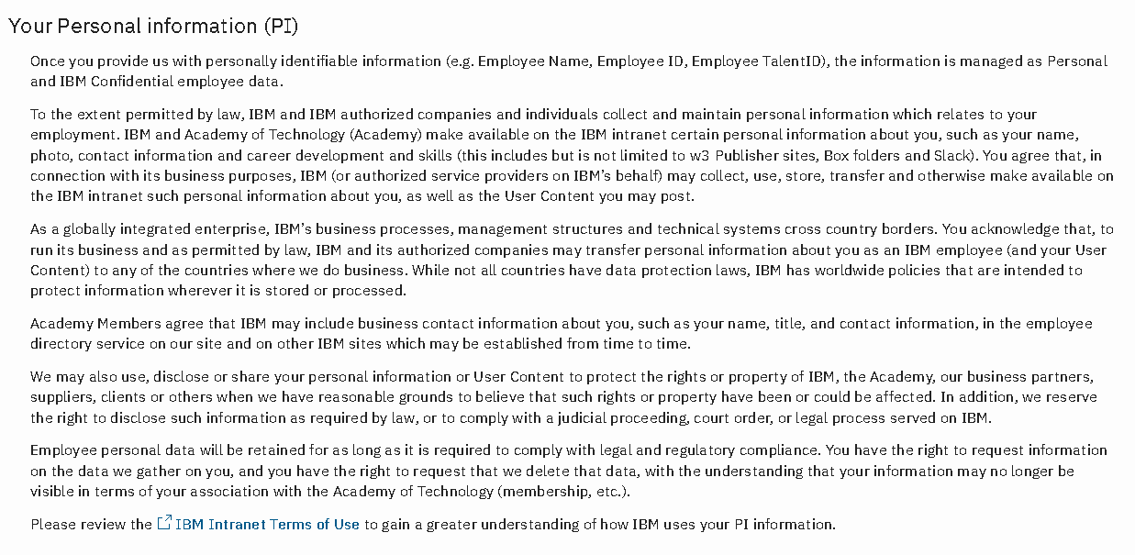
An example of this page can be found from this link - https://aotweb-dev.dal1a.ciocloud.nonprod.intranet.ibm.com/help/terms

